I repainted the teeth to cover up black marks; they have not been refired yet in these pictures.
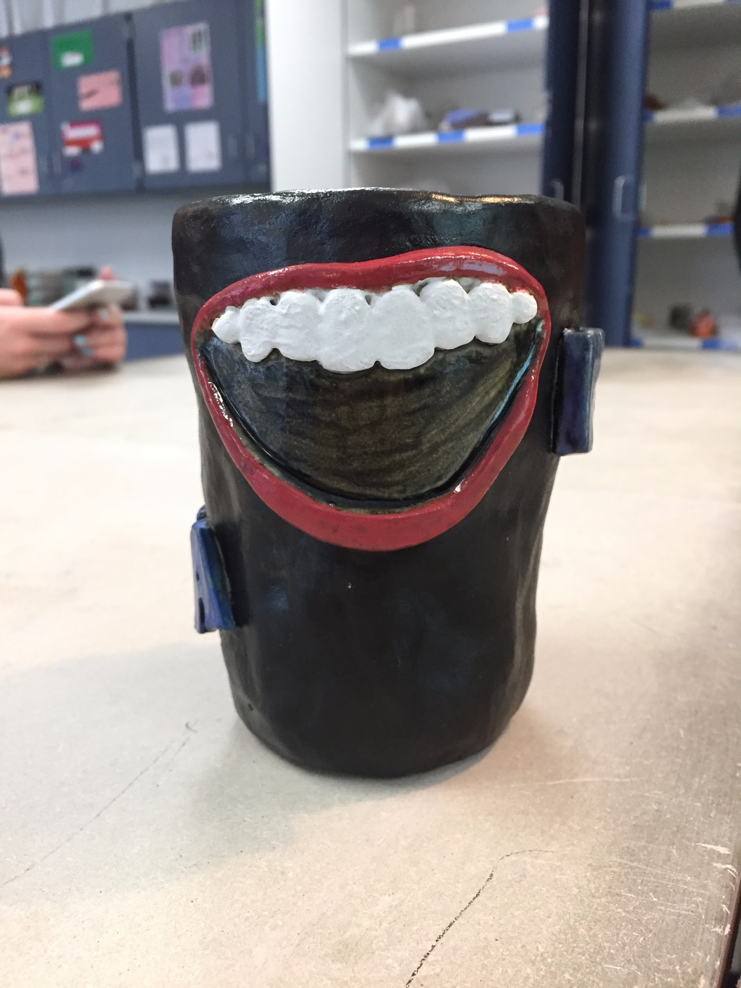
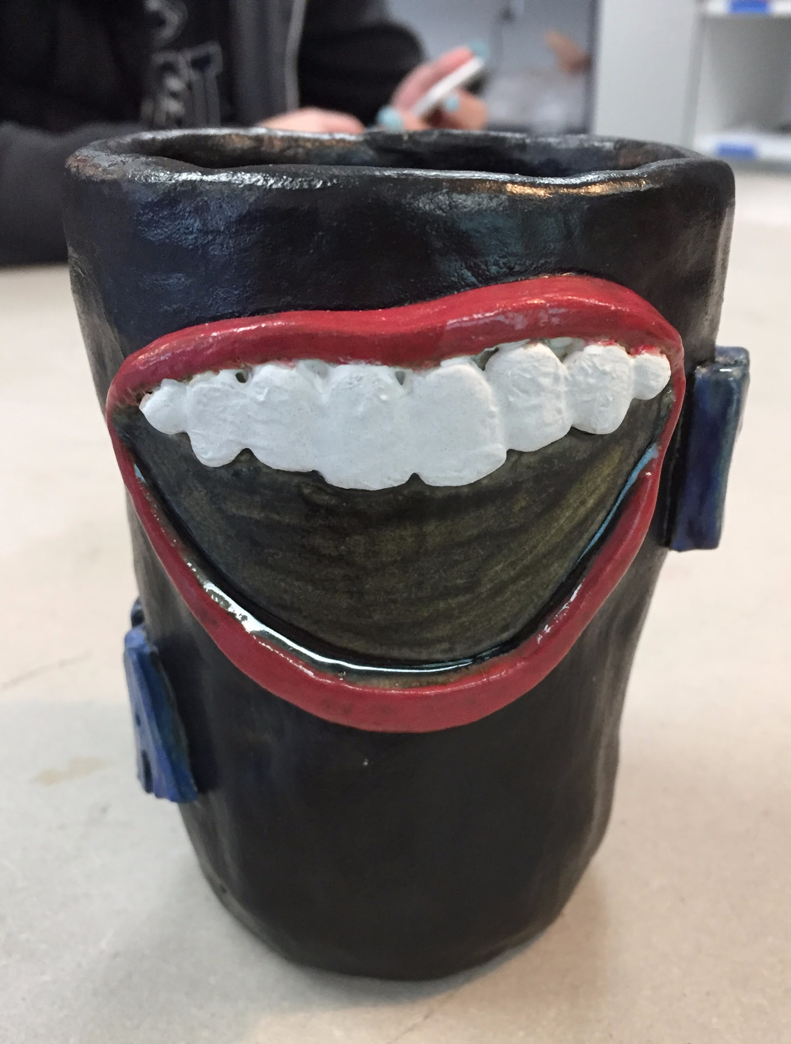

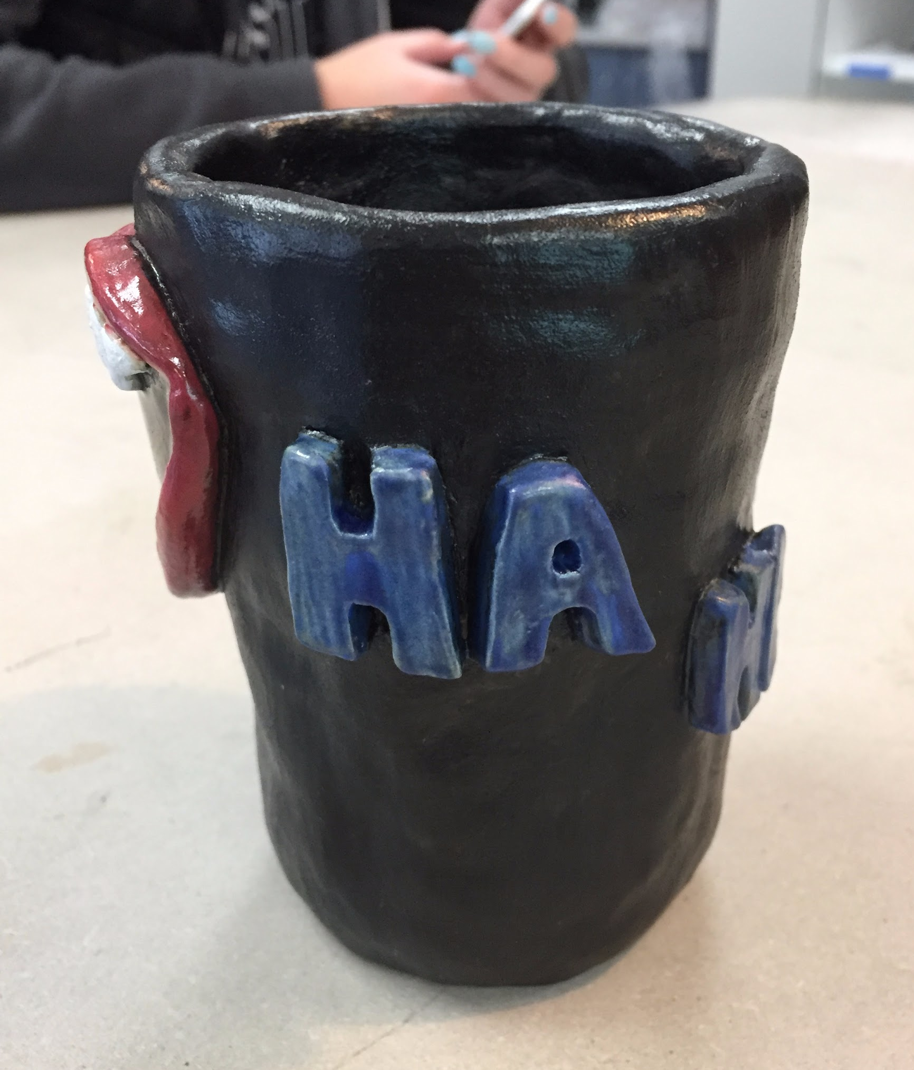
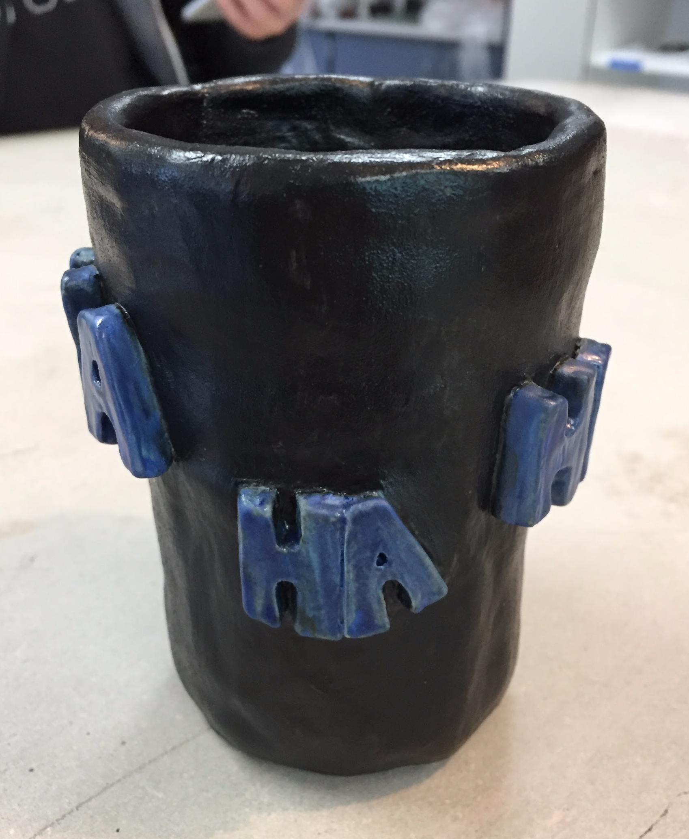
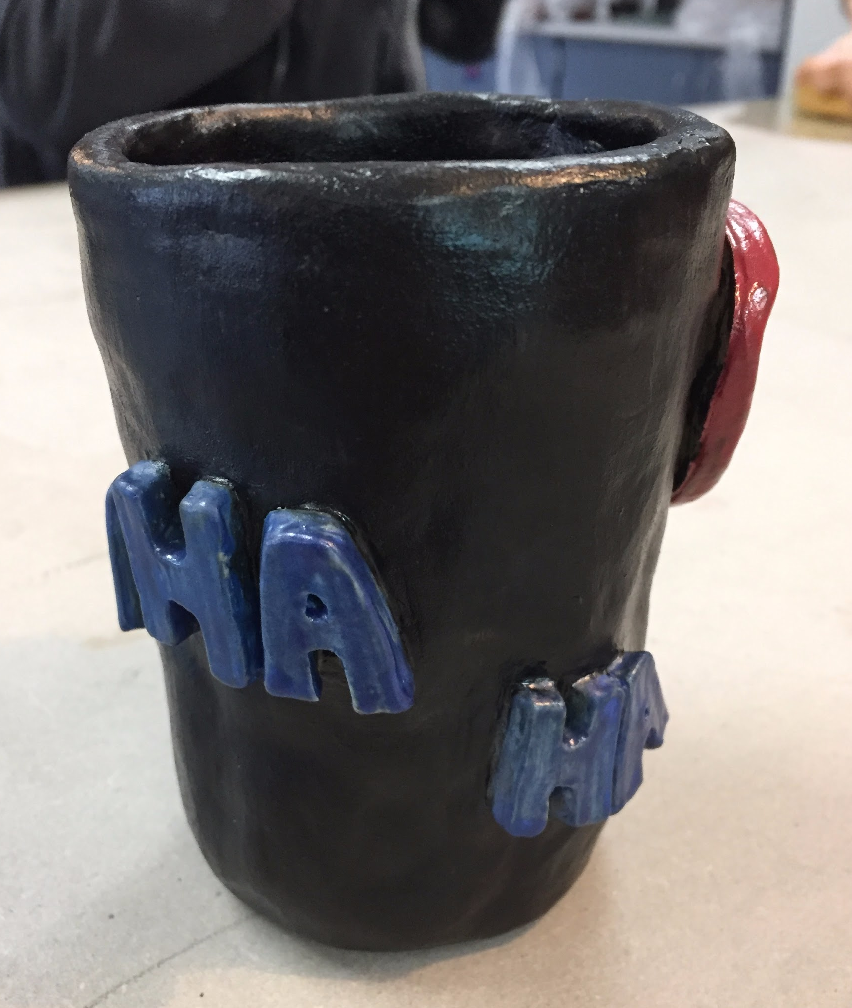

DID WELL
I think I did very well on creating the mouth, which is the focus of my piece. I was worried that it wouldn't look realistic or turn out how I wanted it, but I meticulously worked on creating the shape and adding lips/teeth; it took multiple tries, but in the end, it looks like how I envisioned it in my head. I didn't want it to be a perfectly symmetric shape or have perfectly shaped teeth, which I think would give it a more realistic look to it. It was sort of harder to make it non-symmetric because I'm partially a perfectionist, so the unevenness never seemed “good enough”; nonetheless, I am very proud with how it looks. Besides struggling with the shape and lips, it was a little hard to figure out how big to make it, but I think I made it a good, proportional size compared to the letters. Lastly, since I made the letters blue, I was worried that red would clash and make it look very patriotic (along with white teeth), so I used matcha matte at first. The tile looked like a peachy-red color to me, but it turned out brown; therefore, I used red, and I’m actually very pleased with the richness of the color and how it interacts with the blue. Overall, I am very happy with how the mouth turned out!

IMPROVE
One area I could have done better on is the actual mug itself. As I was creating it, I think I was more focused on actually creating it than making sure it was also smooth and not lumpy. When I added the mouth and letters, I realized that some areas were lumpier than others, which I didn’t like. If I could re-do it, I would spend more time on creating the mug. I would make sure each part was even and consistent before continuing to add coils to make it taller. Also, the inside of my mug was getting dry while the outside was still a little wet, and so the inside was getting sharp because I didn’t smooth that either. There were a lot of sharp edges from the crumbs and just not smoothing it out at all; luckily Ms. Satko suggested getting a wet sponge and using that, which helped a lot. The sponge ended up fixing my problem, but if I re-did this project, I would try to keep the inside consistent, as well, so I wouldn’t have to use the sponge. I definitely think the unevenness of the mug gives it “character”, but I would try to make it a little more polished if I re-did this project.

